Installing App Inventor for FTC – Mr. T notes v1

Probably the most frustrating and difficult phases of learning new development software is actually just getting the software installed properly and everything connected and working.

I was able to install App Inventor today (after hours of head scratching and stumbling blocks) So here are some notes that may help you avoid a couple of roadblocks/mistakes that I hit installing App Inventor.

App Inventor is an icon / block based programming style for Android (similar to Scratch). It will run on Oracle VM VirtualBox a local server you will install as part of the direction.

Go to Team Resources page: <http://www.usfirst.org/roboticsprograms/ftc/team-resources>

Scroll down to Programming Resources and click the App Inventor DownLoad and Resources Link

Open the install guide for your OS (mine is Windows)

and you will carefully follow all the steps. (Don’t assume, follow the steps!)

I had no problems installing VirtualBox by following directions ***until***….

Section 2.8 ……you get to “Installing Device Software” where there are three screens in a row like this one…..

You must click “Install”, don’t jus thit enter or click the highlighted “Don’t Install” (like I did)

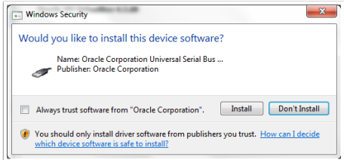

Section 2.11 Installing the Appliance

The download link given in the documents to get AppInventor is not working.

Go here instead…. [https://drive.google.com/open?id=0B0...GRHUDE5ZWFORFE](https://drive.google.com/open?id=0B0z7bZfPuXgQflZJUXpmczU4VTVUWkp5eWREUk1EUVdTVWdzRG5BZXh4UGRHUDE5ZWFORFE)

Click the AI_Images icon

and pick the LocalAppInventor version to download for your computer,

you may have to change to “list view” to tell them apart.

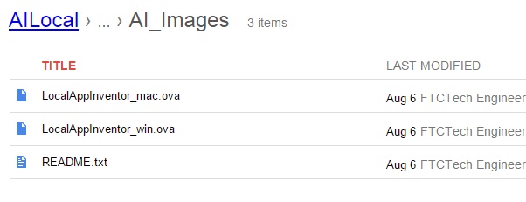

Continue with the directions to Import Appliances…..